6th Professors’ Driven Pile Institute Completed

The Pile Driving Contractors Association completed an extremely successful 6th Professors’ Driven Pile Institute (PDPI) at Utah State University in Logan, Utah from June 19 – 24, 2011. The PDCA is grateful for the very generous welcome and week-long hospitality the professors, instructors and PDCA receive from Utah State University. The PDCA wants to acknowledge H. Scott Hinton, Dean, USU College of Engineering; and Loren Anderson, Jim Bay, and Ken Jewkes for the support this program receives from these dedicated individuals year after year.

The PDCA also wants to recognize Dr. Joseph A. “Joe” Caliendo for his continued support and participation of the program. Joe has been the driving force at USU for the PDPI since the PDCA first showed up in Logan back in 2002. Joe’s dedication and commitment to the PDPI is a major contributing factor in its continued success. “Thanks, Joe!”

The PDCA accepted 21 of the 27 applications for this year’s PDPI program. Professor selection was based on information in the applicants’ resumes, which were submitted to the PDCA earlier this year. Special consideration was given to those professors teaching graduate or undergraduate courses in deep foundations. Attending professors represented Columbia, Georgia Tech, Texas A&M, Penn State, The Citadel, Auburn, USAFA, George Mason, Oregon State, Arkansas, Wyoming, USC, Southern Illinois, Idaho, Lehigh, Connecticut, Louisiana and Utah State.

The PDCA wants to acknowledge the PDCA of the Gulf Coast Chapter who sponsored Professors Greg Smith, University of Louisiana at Monroe. The Gulf Coast Chapter contributed $1000 to the PDPI program on behalf of Professor Smith, as well as covering his travel expenses to and from the PDPI program.

Through the Professors’ Driven Pile Institute, the PDCA has provided the nation’s leading engineering professors with the expertise to teach over 14,700 engineering students about driven pile advantages.

Without question, this program is the standard by which all “teach the teacher” programs are judged and is the best way to ensure the continued progress and strength of our industry for the coming years.

A key component in the increased visibility and marketability of driven piles has been our liaison with academia through the PDCA’s Professors’ Driven Pile Institute. Almost 150 of the nation’s leading engineering professors have completed this intensive and comprehensive five-day educational program that provides attending professors with actual, hands-on, real world experience into the world of driven pile. Professors are exposed to classroom presentations from recognized industry leaders, computer lab exercises and field demonstrations, including dynamic and static testing and driving a 52’ closed-end steel pile. They come away from this course with the knowledge, skill, and materials to teach their engineering students about the value of driven pile.

They are also presented with information explaining the role of the PDCA in the industry and how we are advancing driven piles through technology, education, marketing, and private and public liaisons.

Build, Inc (long-time PDCA member, Bountiful, UT) has been a major supporter and contributor to the PDPI program providing both financial and logistical support since its beginning in 2002. During each PDPI, Build, Inc mobilizes their crane, leads, hammer, material, and crew to set up and drive a closed-end steel pile on-site, which adds greatly to the overall experience of the professors attending the program.

Richard J. Stromness, founder of Build, Inc, committed himself and his company to promoting driven pile. Today, Build, Inc is carrying on Richard’s passion by continuing to drive pile throughout Utah and the surrounding states and as a recognized leader in the pile driving industry.

In 2007 the PDCA established the Richard J. Stromness Award of Excellence to honor Richard and the commitment Build, Inc has made to the PDPI. The award is presented to a PDPI student who displays enthusiasm, participation and excellence in attitude while attending the PDPI.

During the PDPI, the attending students are asked to nominate one student who displays these unique qualities. In 2011, the students nominated Logan Brant, Columbia University as the recipient of the Richard J. Stromness Award of Excellence. PDCA congratulates Logan, who displayed all of the qualities representative of this prestigious award.

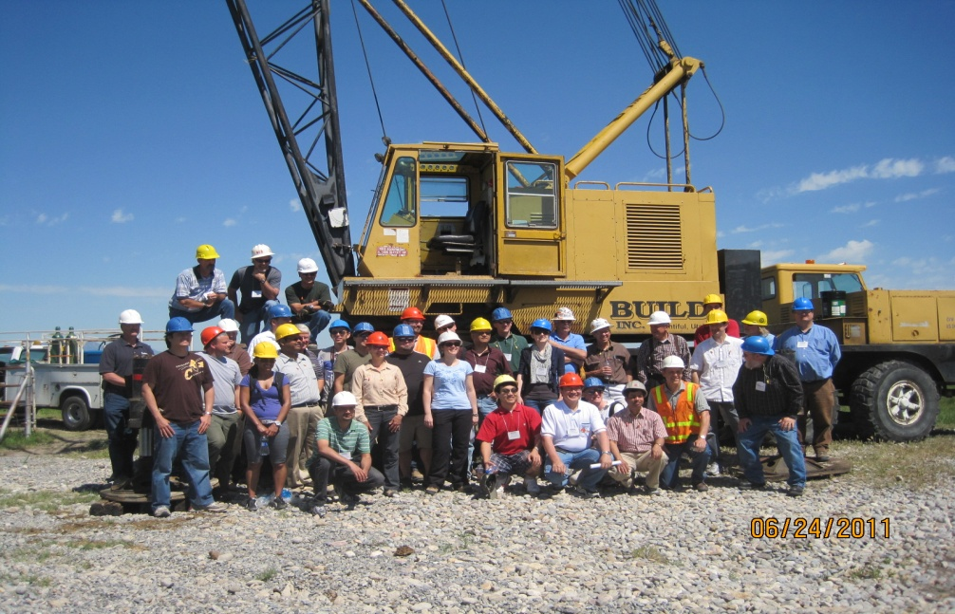

2011 Professors’ Driven Pile Institute
Contributing PDCA Member Companies
(In Alphabetical Order from L to R)

In 2011, PDCA members contributed $14,090.00 to the PDPI. The PDCA would like to acknowledge those members who recognize the value of the PDPI program and made a generous contribution to help support this important program.

Contractors
Alaska Interstate Construction, LLC  Austin Bridge and Road, LP  Boh Bros. Construction Company, LLC  Coastal Bridge Company, LLC  Continental Construction Company  CS Marine Constructors, Inc.  E. C. Korneffel Company  Ed Waters and Sons Contracting Company, Inc.  F. Miller Construction, LLC  George Harms Construction Company  Glenn O. Hawbaker, Inc.  Halverson Construction Company  Herbert F. Darling  Kostmayer Construction Company  L&A Contracting Company  L. H. Bolduc Company, Inc.  Manhattan Road and Bridge  MB Western Industrial Contracting Company  P&H Construction Corporation  Parker Marine Contracting Corporation  Precast Piling Technology, inc.  R. Kremer & Son Marine Contractors, LLC  Richard Goettle, Inc.  Stroer & Graff, Inc.  Texas Gulf Construction Company, Inc.  Weeks Marine, Inc.  ASAP Installations  Marion & Moultrie Dockbuilders | American Deep Foundation & Shoring, Inc.  Blue Iron Foundation and Shoring, LLC  Cajun Deep Foundations, LLC  Commerce Construction Corporation  Corman Marine Construction, Inc.  DeWitt Construction, inc.  Easter Bridge, A Division of Sloan Construction, Inc.  Edward E. Gillen Company  Foundation Constructors, Inc.  Giken America Corporation  Gulf South Piling and Construction  Hawaiian Dredging Construction Company  Jet-Drive General Marine Contractor Company  Kuhn Construction Company  L.G. Barcus & Sons, Inc.  Lawrence Construction Company  Mason Construction  Orion Construction  Pacific Pile and Marine, L.P.  Piling, Inc.  R.E. Burns & Sons, Inc.  Richard E. Pierson Construction Company  Simpson & Brown, Inc.  Taylor Bros. Marine Construction, Inc.  Underpinning & Foundation Skanska, Inc.  West Construction Company  Ford Pile Foundations  Signor Enterprises

Associates
American Piledriving Equipment  Bermingham Foundation Solutions  Hydraulic Power Systems  Jinnings Equipment  Mandal Pipe Company  Mississippi Valley Equipment Company  Naylor Pipe Company  Northwest Pipe Company  Pile Dynamics, Inc.  Pipe and Tube Supplies, Inc.  Robishaw Engineering, Inc.  Skyline Steel Corporation  Valiant Steel and Equipment, Inc.  DFP Foundation Products, LLC  Flagler Construction Equipment, LLC  Goble PileTest, Inc.  Whitaker Laboratory, Inc. | Bayshore Concrete Products  Gulf Coast Pre-stressed, Inc.  IHC Hydrohammer B.V.  Lally Pipe& Tube  Mississippi River Equipment Company  Monotube Pile Corporation  New England Construction Products, LLC  PACO Ventures, LLC  Pipe and Piling Supplies  Platinum Grover Int. Inc.  Roll Form Group  Trinity Products  Varsteel  Essve Tech, Inc.  Foundation Testing and Consulting, LLC  Van-Smith Concrete Company

Engineering Affiliates
CH2M Hill  Robert Miner Dynamic Testing, Inc.  California Prison Industry Authority | Haley & Aldrich, Inc.  Staytowers Group, Inc.

SPECIAL RECOGNITION

The PDCA would like to thank all of the individuals who made presentations or contributed in some way to the success of the 6th Professors’ Driven Pile Institute. The PDCA is grateful to all of these individuals, who contributed their time, energy and resources to the PDPI and ask nothing in return, but an opportunity to help the industry and the PDCA.

George Goble (Goble PileTest)  Pat Hannigan (GRL Engineers, Inc.)  Aaron Budge (Minnesota State Univ.)  Joe Caliendo (Utah State University)  Kyle Rollins (Brigham Young)  Garland Likins (Pile Dynamics, Inc.)  Billy Camp (S&ME)  Jerry DiMaggio (Jerry A. DiMaggio Consulting, LLC)  Brian Anderson (Auburn University)  Van Komurka (Wagner Komurka Geotechnical Group)  Loren Anderson (Utah State Univ.)  Jim Bay (Utah State University)  Buck Darling (Herbert F. Darling)  Eric Hendriksen (Build, Inc.) | Driven Pile Design Process, Wave Mechanics, Real Time Pile Driving Measurements with PILE CHECK, Field Events  Pile Types, Special Design Considerations, Pile Driving Equipment, Wave Equation Applications, GRLWEAP Computer Workshop, Dynamic Measurements, Case Method, PDA Measurements, Field Events  Negative Skin Friction (downdrag), Field Events  Geotechnical Considerations, Driven Pile Construction Specification, Field Events  Axial and Lateral Static Load Testing, Design Parameters from Load Testing  Wave Equation Modeling GRLWEAP, GRLWEAP Computer Workshop, Dynamic Measurements, Case Method, PDA Measurements, CAPWAP Background and Examples, Field Events  Driven v. Drilled – Deep Foundations, Field Events  LRFD Considerations for Driven Pile Design  FB – PIER Computer Program, FB – PIER Computer Workshop  Economics of Driven Pile Foundations: Soil/Pile Set-Up and Support Cost Components with Case Studies, Field Events  Site Characterization, Field Events  Site Characterization, Field Events  Contractors Perspective on Driven Pile  Contractors Perspective on Driven Pile

Additional Support during Field Events was provided by the following companies. The PDCA is grateful for their support and participation.

Build, Inc. – Pile Driving and Load Test Fabrication and Set Up
Campbell Scientific – Data Collection
Conetec, Inc. (Salt Lake City, Ut) – Cone Penetrometer Demonstration
Goble PileTest, Inc. – Real Time Pile Driving Measurements
Jay Apedaile Drilling – Soil Sampling and SPT Measurements
Pile Dynamics, Inc. – Dynamic Load Testing, PIT Testing
S&ME – Load Testing Supervision

Special Recognition goes to Joel Komurka, who assistance during the Field Events proved invaluable – especially to his Dad, Van.

Field Events included:
Pile Driving of closed-end pipe pile with dynamic testing and pile check, re-strike of an existing pile to check for set up, axial and lateral static load tests, pile integrity testing, SPT Energy Measurements, and CPT demonstrations.

12th Annual Design and Installation of Cost-Efficient Pile Conference Scheduled

The Pile Driving Contractors Association, in partnership with the PDCA of Florida Chapter will host the 12th Annual Design and Installation of Cost-Efficient Piles – The E³ Conference in Orlando, Florida on Thursday, November 3, 2011.

Maximize Driven Pile Efficiency, Effectiveness and Economy – E³ !

Who Should Attend?

The DICEP conference is designed for geotechnical, structural and civil engineers; contractors and other firms or individuals who support, conduct business or are associated with the deep foundations, earth retention and/or driven pile industry.

PDH?

The PDCA is approved by the Florida Board of Professional Engineers to provide Professional Development Hours (PDH). All conference participants will be issued a certificate for 6 Professional Development Hours (PDH) for attending this conference.

Exhibitors!

All presentations and functions will be held in the same area as the exhibit hall to maximize exhibitor traffic. Exhibitor space will accommodate 6’ table tops ONLY. Exhibitor fee is $400.00. Exhibitor registration includes exhibit space and full conference registration for one person. The PDCA will assign space on a first-registered and paid-in-full basis.

More Information . . .

The PDCA has more information, including a full conference brochure and registration form on the association’s website, www.piledrivers.org or call the PDCA at 888-311-PDCA (7322).

Don’t Miss the Premier Engineering and Contractor Focused
Driven Pile Seminar – November 3, 2011

2012 Annual Conference – Land of Enchantment

The PDCA has selected New Mexico, the “Land of Enchantment” as the site of the PDCA’s 16th Annual International Conference and Expo 2012. The PDCA will be in Albuquerque, NM at the Hyatt Regency Albuquerque from Wednesday through Friday, April 25 – 27, 2012. With daily average April temperatures at 70 degrees F and the sun shining 79 % of the time, we could not have picked a better spot to host this conference.

The Hyatt Regency Albuquerque is the only Four-Diamond hotel in downtown Albuquerque and is highly regarded for its renowned services, upscale amenities and ideal central location to the uniqueness of this historic city. Located just 10 minutes from the Albuquerque International Sunport, the hotel is easily accessible by shuttle or taxi.

Preparations for this special annual event are underway. The program will include many of the traditional PDCA activities, such as informative General Sessions, Exhibit Hall, Golf Tournament, Business and Awards Luncheon, Receptions, Social and Business networking, Companion’s Program, Annual Dinner and special guests.

A few quick highlights – the PDCA will be the only group at the Hyatt, so we will have all the meeting space with no interference from other groups. We will have a Keynote speaker at the Opening Ceremony and a special guest at the annual dinner. Golf enthusiast can play in the PDCA 5th Annual Golf Tournament at The Championship Golf Course, University of New Mexico – host to 5 NCAA Golf Championships. The PDCA is planning a Companion’s Program with visits to the plateau villages of the Pueblos of Acoma to provide our companion participants with a unique Native American cultural experience. The PDCA is also planning an “ala carte” program for anyone interested in taking to the skies in a hot air balloon – for the adventurous type, this is an opportunity you do not want to miss.

The PDCA will be finalizing the conference specifics soon, so watch the PDCA website and emails for more information. Mark your calendars now for April 25, - 27, 2012 to be in Albuquerque, NM with the PDCA.

PDCA Website

The PDCA recently modified our website, www.piledrivers.org, adding some additional features that will further enhance your association, businesses and our industry. Most of the changes occur “behind the scene”, so you won’t necessarily see them from a visual perspective, but they will make the site better. Visual changes include additional links in the following areas:

Professors’ Driven Pile Institute – Lectures from 2011 (2009 is being uploaded soon), PDPI Photos and a PDPI Video

Gallery – General Pile Driving Equipment and Job Site Photos, PDCA Event Photos (Chapters send us your photos), PDPI Event Photos and Video Links.

PDCA News now includes Member News and Chapter News. Member News is for companies who have General Announcements to make about their company. Announcements can be about promotions, new hires, civic or industry awards, new project awards or project completions. Please keep in mind that this section is NOT for advertising and submittals will be reviewed for proper content before uploading.

Chapter News is intended to benefit all PDCA Chapters, allowing them to announce upcoming events, special meetings, elections, etc. Information can be submitted to the PDCA for uploading.

The PDCA has also made changes to the Leadership/Committees” tab, providing the PDCA Board of Directors space to upload pictures and short bios, so the members and guests to the PDCA website can find out more about the leadership of your association. Board members have been requested to send “head shots” and bios, so this feature can be completed as quickly as possible.

To continue as a resource to the industry, the PDCA has added a link on the home page, titled “Qualified Support For Dynamic Measurement and Analysis Testing”, which will take the user to links for “America” and “International” qualified individuals who can perform dynamic measurement and analysis testing.

But Wait . . . There’s more!

How many “hits” does the PDCA website get on a monthly basis? What about yearly? Don’t be surprised – the PDCA is a resource to our members, industry and guests and all are using it! The PDCA is averaging over 8,000 visits a month with over 4,000 of those monthly “hits” coming from “unique visitors”. The PDCA has had 956,786 “hits” since January 1, 2011 (as of August 1, 2011). The top countries using the PDCA website in numerical order (pages/hits) are the United States, Qatar, Great Britain, China, Canada, India, Netherlands, Hong Kong, Australia, and Germany. Member Search ranks 3rd as the page most viewed – keep in mind, they have to go to the home page first to get to the Member Search, so realistically, the Member Search page ranks 2nd as the most active page. Do you think there are people out there looking for you??

Over 83% are connecting to the PDCA website from our direct address (www.piledrivers.org) or through a bookmark (already have our URL in their system).

Now I want to tell you about another new feature on the PDCA website. If you go to www.piledrivers.org, and scroll down the home page (or any page for that matter) you are going to see PDCA website advertisers, including Foundation Constructors, ArcelorMittal / Skyline Steel, and ICE – you will also see the PDCA Logo, but it is just holding advertising space for your company. If you realize the value of the information above, then you can realize the potential you company will have advertising on the PDCA website to reach your target market.

Advertising rates are very reasonable! Call the PDCA office at 888-311-PDCA (7322) for more information.

Welcome New PDCA Members

Contractor  Hayward Baker, Inc.  Kevin Lewis  208 Little Santee Rd  Colfax, NC 27235  Phone: 336-668-0884  Fax: 336-668-3259  www.haywardbaker.com  kclewis@haywardbaker.com  Miller Bros. Construction  Randall Zeisloft  PO Box 70  Archbold, OH 43502  USA  Phone: 419-445-8110  Fax: 419-445-8212  www.millerbrosconst.com  randyzeisloft@MBCholdings.com  Shimmick Construction Company, Inc.  Scott Laumann  8201 Edgewater Drive, Suite 202  Oakland, CA 94621  USA  Phone: 510-777-5000  Fax: 510-777-5099  www.shimmick.com  slaumann@shimmick.com  Mid-Gulf Foundations, LLC  Tom Howard  7989 Pecue Ln Ste. 5E  Baton Rouge, LA 70884  USA  Phone: 225-752-0404  Fax: 225-752-0404  thoward@midgulfllc.com | Associate  American Equipment & Fabricating Corp.  Joe Gelardi  100 Water St  East Providence, RI 2914  USA  Phone: 401-438-2626  Fax: 401-437-0764  www.american-equipment.com  j.gelardi@american-equipment.com  Independence Tube Corporation  Jim O’Shea  6226 West 74th St  Chicago, IL 60638  708-496-0380  708-563-1950  www.independencetube.com  joshea@independencetube.com  Parker Hannifin Corp - Hose Products Division  Angela Brown  30240 Lakeland Blvd  Wickliffe, OH 44092  USA  Phone: 440-516-3285  www.parker.com  angela.brown@parker.com  PSL North America  K.Kaye Linkendhoger  13092 Sea Plane Rd  Bay St. Louis, MS 39520  USA  Phone: 222-822-1823  Fax: 228-533-7768  www.pslna.com  klinkenhoger@pslna.com

